Microsoft One Drive & Office 365
(Free Cloud Storage) & (lots of powerful software programs)

Students have free access to use the powerful Microsoft Office 365 Software by signing into their school e-mail account or Office 365.
From their school e-mail (Outlook), students click on the waffle icon (the nine dot icon to the left of Office 365) to access all of the Microsoft software including the One Drive.

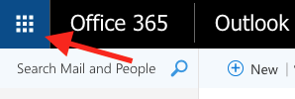

Students can freely use Microsoft Word to write papers, they can use Power Point to create presentations, One Drive to save their files, and OneNote to keep notes for their classes.

I recommend that students download the One Drive App from Microsoft on their phone.
This way students can easily save photos from their phone and move them into the One Drive so they can assess them on their computer at school or anywhere in the world. The One Drive is a cloud storage device that students have so they can save their files or photos for school while they are a student in Utica Community Schools. This way students do not need a USB storage drive or a charging wire to upload or download their photos, files or assignments.

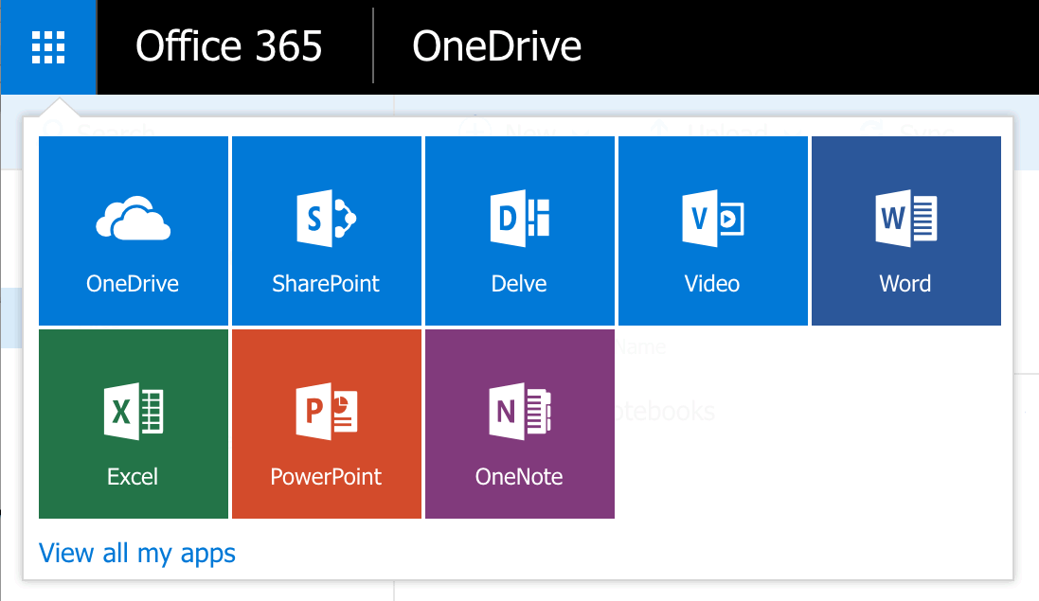

Students can assess all of Office 365, including One Drive to upload or download photos or files anywhere in the world they have their phone or a computer with an internet connection.

