Light comes from one side on the cup cake, frosting and fruit.
Object Shadows and Cast Shadow are on the opposite side of the light source.
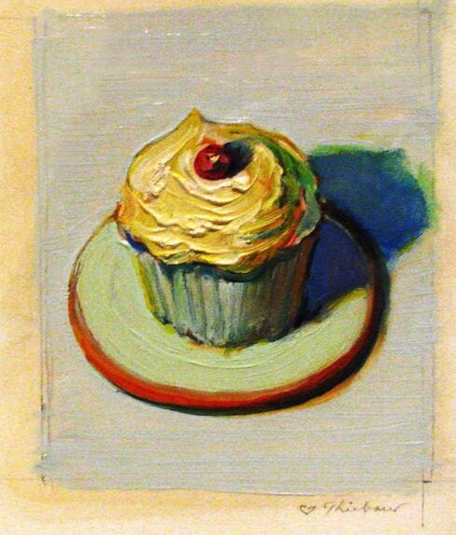

Wayne Thiebault used strong cast shadows.
Notice how the shadow of the fruit and cupcake go in the same direction.
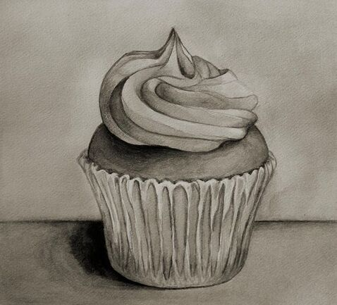

Cast shadow on the table on left.
Cast shadow on the cupcake top left.
Light side of objects on Right.

Make the frosting lighter than your cupcake.
Carefully Blend with a paper towel or stump or tortillon.

