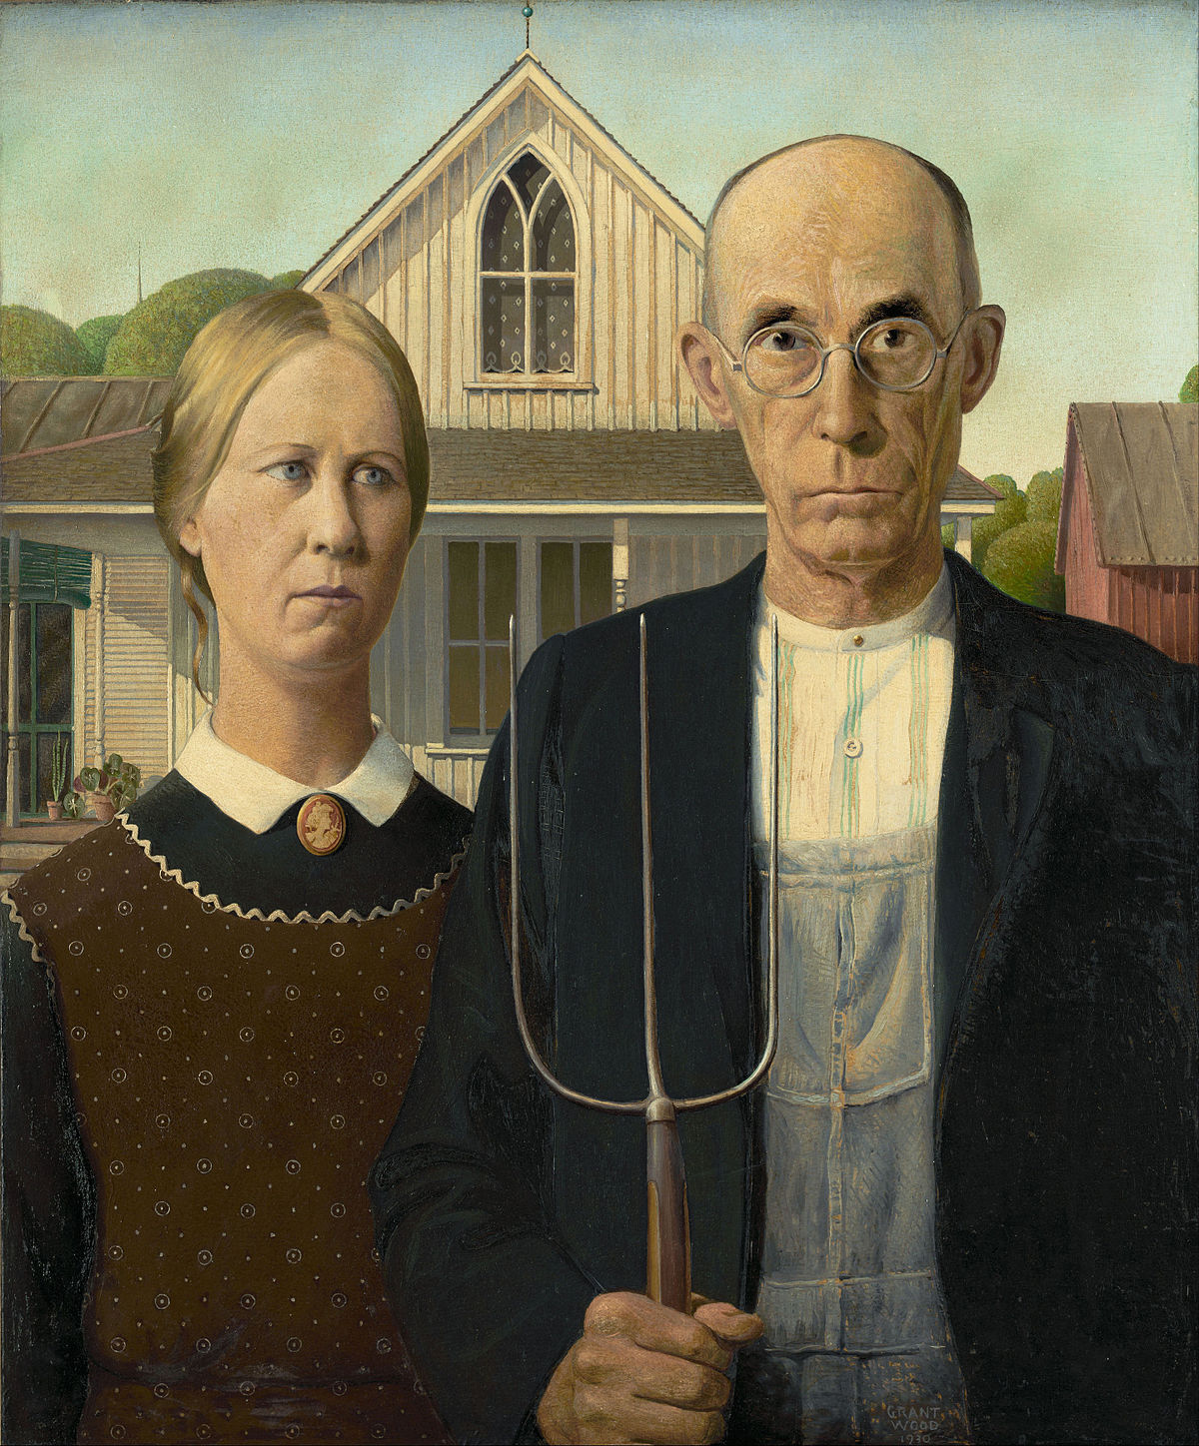

Color or shade it neatly.