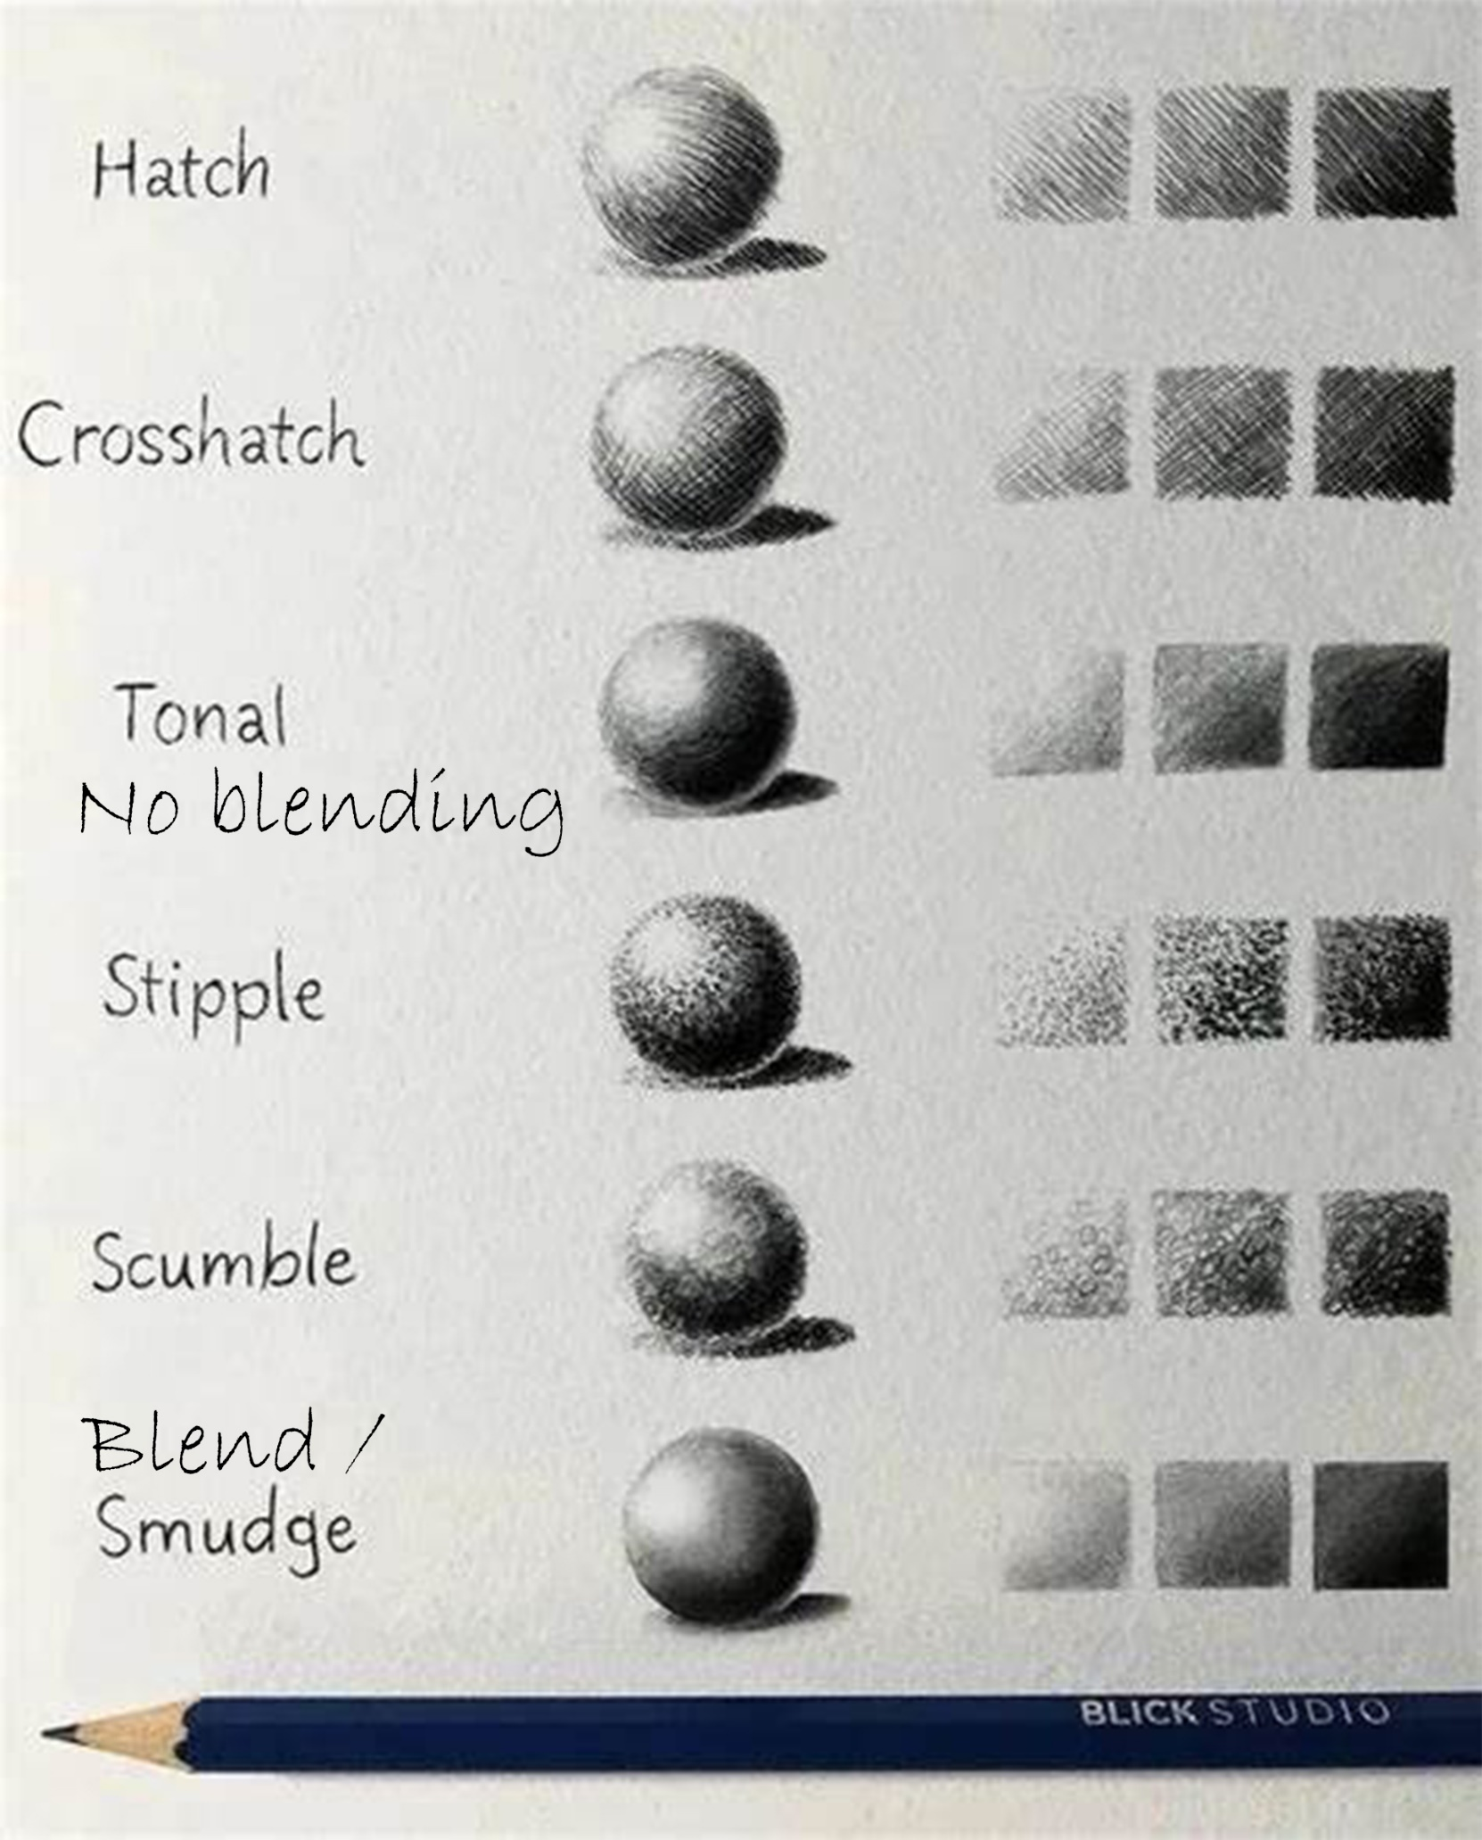

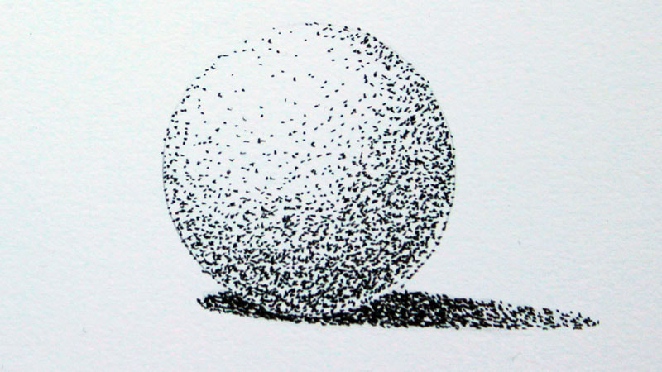

Stippling is made with little dots. Crosshatching is diagonal line in two different directions.

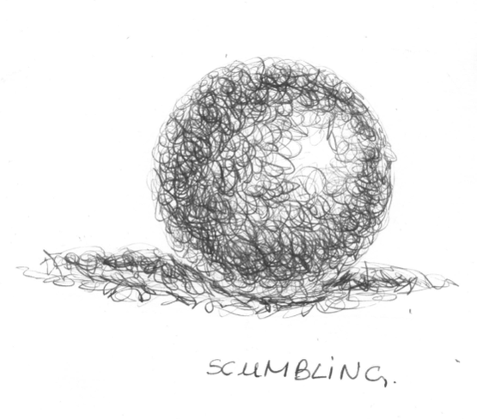 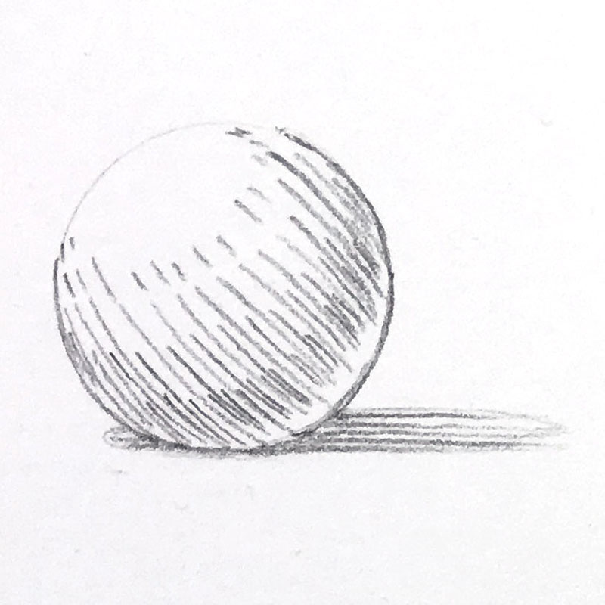Scumbling looks like little S shapes or C shapes. Hatching is made with short diagonal lines. 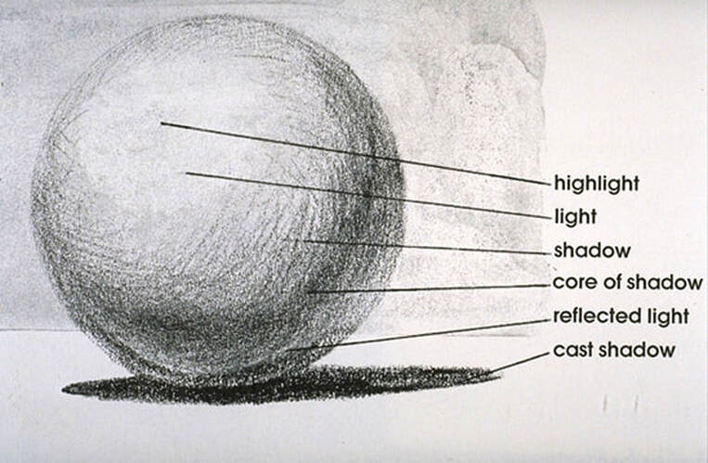 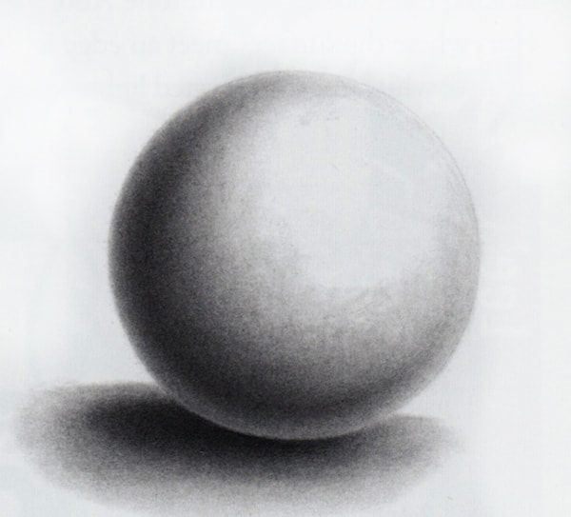

Tonal drawings show your line work. (no blending) Blending (smears the graphite)